[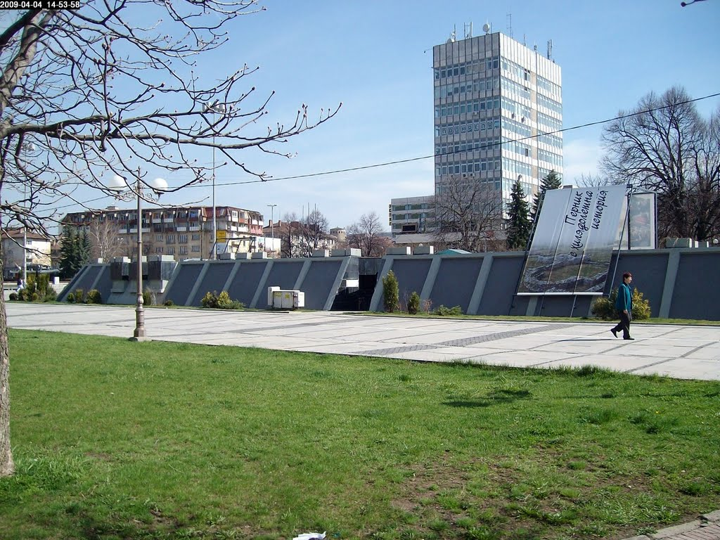](http://www.google.bg/url?sa=i&rct=j&q=&esrc=s&source=images&cd=&cad=rja&uact=8&ved=2ahUKEwjdi_qfrPDZAhWDLlAKHex3CHgQjRx6BAgAEAU&url=http%3A%2F%2Fmapio.net%2Fpic%2Fp-44906989%2F&psig=AOvVaw0qQS7ovLCx8iYeZyzThU8k&ust=1521272608069457)

[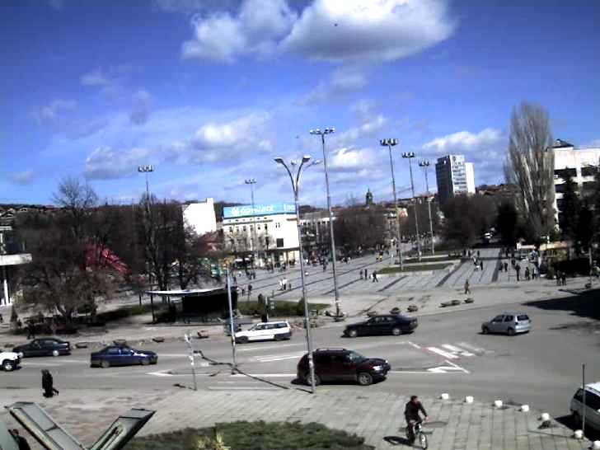](http://www.google.bg/url?sa=i&rct=j&q=&esrc=s&source=images&cd=&cad=rja&uact=8&ved=2ahUKEwiA0KzlrPDZAhVIYVAKHamtADgQjRx6BAgAEAU&url=http%3A%2F%2Ffree-webcambg.com%2FPernik-01-webcam-live-online-camera-center-kameri-na-jivo-vremeto-weather.htm&psig=AOvVaw1xm598IxyzB3ajhsORGGtN&ust=1521272756912749)